1. **Agenda**:

The structure of every **Git Object**.

1. Diagram

   Description automatically generated
   1. Every Git Object is consisting of 4 fields 🡺 **Object Type, Length, Delimiter & Content.  
      NOTE:** No matter, how an object is created using **git hash-object** or using high-level command **git add**, it has 4 fields and same structure.  
      **How we can prove this?**We can prove it by two ways:
      1. By reading the content of the Git Object (Blob) directly.
      2. By creating the SHA1 hash of the content as per structure as shown in the slide by using the **shasum** and comparing the hash with that generated by **git hash-object**.
   2. **Read Carefully, it will help**:   
      actually, it is about what is the final input that is given to **git hash-object** and **shasum** when hashcode is calculated.
2. Chart

   Description automatically generated with low confidence  
   Actually, “cat” doesn’t know how to uncompress the content of compressed file.
3. 
4. We will use the 2nd way of verifying the structure of Git Object  
   2nd Way 🡺 Generating the SHA1 HashCode by passing the assumed structure to both utilities 🡺 **git** **hash-object & shasum**.  
   Diagram

   Description automatically generated
5. Text

   Description automatically generated
6. **NOTE**: Before generating hashcode, please echo some characters with null character without -e, see if null is being printed or not. If printed, then please include -e (escape null character) while generating hashcode.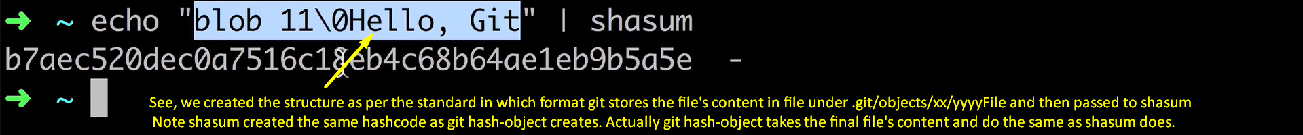  
   If you don’t know how we calculated the content parts in structure, use the following commands  
   You must know the Hashcode for the blob. Say it is ae12  
   git cat-file **-t** ae12 🡺To get **type** 🡺 Like blob  
   git cat-file **-s** ae12 🡺To get **size** 🡺 Like 11  
   git cat-file **-p** ae12 🡺To get **Content** 🡺 Like Hello, Git